Reading Strategies (閱讀策略學習單) 新莊國中 曾麗娜
(以102年特招閱讀題組23-24題為例)
前言
教科書文本受限於單字量及目標句型，鮮少有需統整、綜合及分析能力的
文本。然而會考精熟級的表現標準描述為「能整合應用字詞、語法結構，
能理解主題較抽象、情境較多元且語句結構長而複雜的文本，並能指出各
類文本的主旨及作者立場。」因此，閱讀策略的教學引導為英語教師必備
之教學知能。

教學步驟
Step 1: Predict (預測)
閱讀文本前，請學生先由標題
A VISIT FROM SOMEONE FROM YOUR OWN BOOK!
This Winter’s Most Heartwarming Movie
猜測文本的內容與什麼有關。
建議先採用開放式填答，讓學生思考可能的答案。
Look at the title. What do you think the reading is about?
Answer: ___________
亦可依據學生程度，採用選擇題方式提供學生可能性答案選項。
- A book. (B) A movie. (C) A season. Answer: (B)

Step 2: Skimming (略讀)
快速閱讀文本並找出文本提到最多的議題或事物是什麼？
Look through the article quickly. What is this article mainly about? (這個步驟reconfirm 前一步驟 確認 prediction的正確性)
Answer: ____________
建議以開放式填答為主，讓學生思考可能的答案。再依學生回答情況，提供
可能之選項。
(A) A book. (B) A movie. (C) A season. Answer: (B)

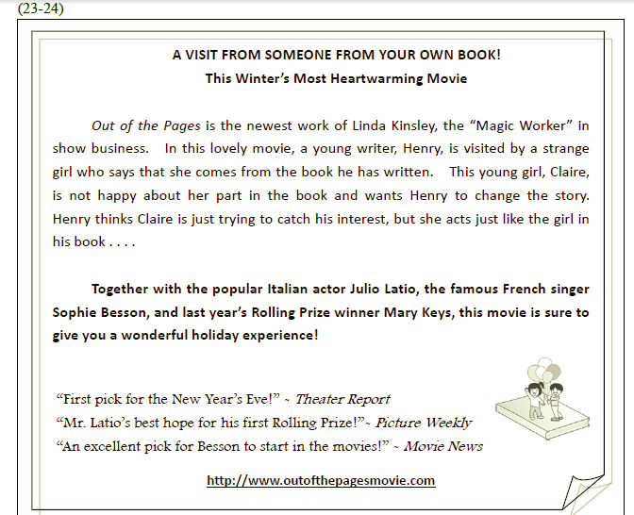
Step 3: Scanning (掃讀)
請學生仔細閱讀文章，並且在文章中提到的人名底下畫線。問學生：共有幾個人呢？Read the article again and underline the names of the people mentioned in the article. How many names can you find?
Answer: Linda Kinsley; Henry; Claire; Julio Latio; Sophie Besson; Mary Keys
(6 people)
Step 4: Look for details (找出細節)
這些人物的特色是什麼呢？請再仔細閱讀文章、找出答案並填入下列表格。
What do you know about these people? Re-read the article and find out some information about these people. And put down the information in the table.

Name | Job | What about
Linda Kinsey | Show business | Out of Pages (the newest work)
Henry | writer | -a young writer in the movie  -visited by Claire  -doesn’t believe what Claire said
Claire |  | -a young girl in Henry’s book  -not happy about the part in the book  -wants Henry to change the story
Julio Latio | Italian actor
Sophie Besson | French singer
Mary Keys |  | Rolling Prize Winner (last year)

Step: 5: Read & Think (讀一讀、想一想)
此教學步驟重點在於提問文本中需深度思索的問題。 同樣地，以開放式填空為
主，並請學生指出答案線索在何處？
- What is “ Out of the Pages”? Answer:_______ The clues:______
可依學生程度及答題狀況提供可能選項
- A book (B) A movie (C) A theater
Answer: (B)
The clues: Line 2 (in this lovely movie)

- “This movie is sure to give you a wonderful holiday experience.” What might be the “holiday” that the author talks about? Answer:_______ The clues:______
可依學生程度及答題狀況提供可能選項
- Valentine’s Day (B) Halloween (C) New Year
Answer: (C)
The clues : The title and Line 10

- What does “Mr. Latio’s best hope for his first Rolling Prize!” imply (暗示)?
Answer: Mr. Latio did a great job in the movie and may win the Rolling Prize. The Clues: _______________
若學生想不出答案，可提供以下二個參考選項，協助學生找到問題核心。
- Mr. Latio has won a Rolling Prize.
- Mr. Latio hasn’t won any Rolling Prize yet.
Answer: (B) The clues: best; hope; first

- What does “An excellent pick for Besson to start in the movies!” imply (暗示)?
Answer: This movie is a good starting point for Besson’s acting career.
The Clues: _______________
若學生苦無答案，可提供以下二個參考選項，協助學生聚焦。

- This is Besson’s first movie.
- Besson was a movie star before.
Answer: (A) The clues: start in the movies

Step 6: Draw a mind-map of the reading （繪製心智圖）
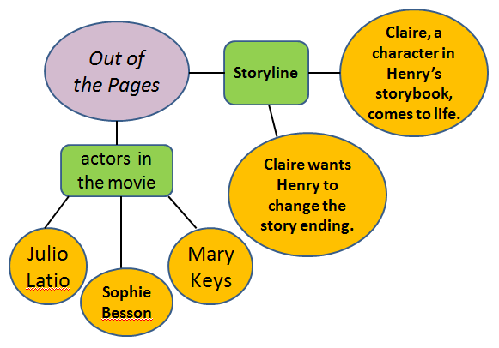
Step 7: Give it a try (小試身手)
經過先前六個閱讀策略引導學生閱讀文本後，接下來請學生試做會考試題。
23. What does the reading say about the story of the movie?
(A) It happens in snowy winter.
(B) It comes from a popular book.
(C) Henry does not believe what Claire says when they first meet.
(D) Henry does not know how to change the story of his book for Claire.
Answer: (C)
Clues: Line 5 (Henry thinks Claire is just trying to catch his interest, but she
acts just like the girl in his book.)

24. Which do we know from the reading?
(A) Out of the Pages is Sophie Besson’s first movie.
(B) Out of the Pages has won Julio Latio a Rolling Prize.
(C) Out of the Pages is Linda Kinsley’s best-selling work.
(D) Out of the Pages has won Mary Keys a best actress prize.
Answer: (A)
Clues: An excellent pick for Besson to start in the movies.
Step 8: Question Masters (提問高手)
依據文本以5W1H (who; where; what; when; why; how ) 寫出一個提問。
Write down one question about the reading.
____________________________________________________

Step 9: After Reading (延伸活動1)
此篇文本情節與電影「口白人生」極為類似，適合在班上結合生命教育議題，引導學生深度思考人生哲理。程度好的班級亦可進行文本仿作。此延伸活動教師可視教學時數及班級程度彈性運用。

Play the movie trailer of “Stranger than Fiction.”
(American comedy-drama-fantasy 2006)
https://www.youtube.com/watch?v=26FBhM_pjoc

Discuss with your partner:
- How do you feel if you were Harold (the main character in the movie “Stranger than Fiction”)?
- If you were Karen (the writer) of “Stranger than Fiction”, would you change the ending of the story?
- What is the thing you want to do the most on the last day of your life?
Step 10: Extension(延伸活動2)
Make a poster to promote your favorite movie!
- The name of the movie
- The characters (角色)
- The plot (情節)
- What’s so special about the movie?
- When will the movie be in theaters (上映)?
- The comments from the press/movie reviews (媒體影評)

