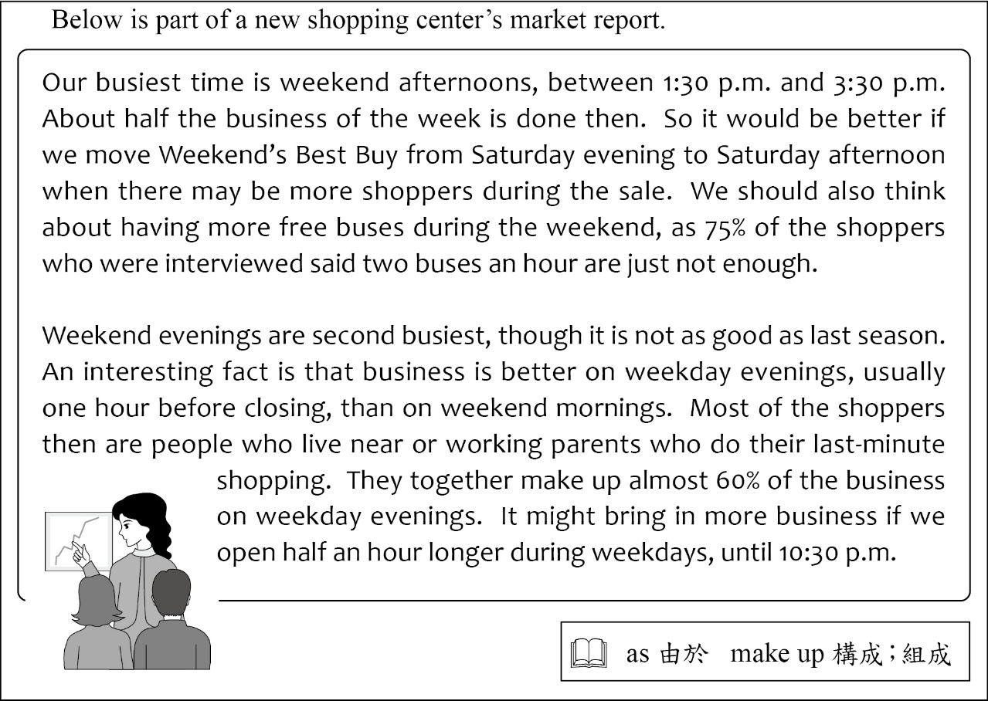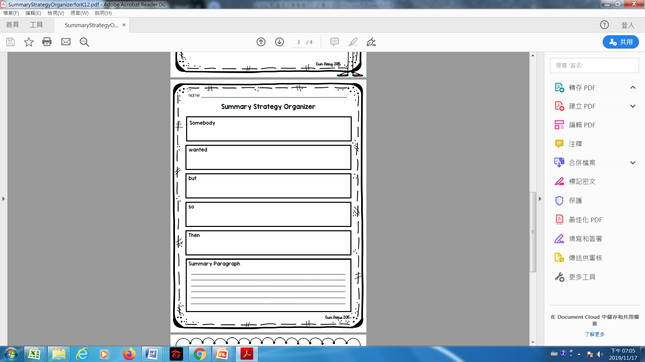108.12.06講義

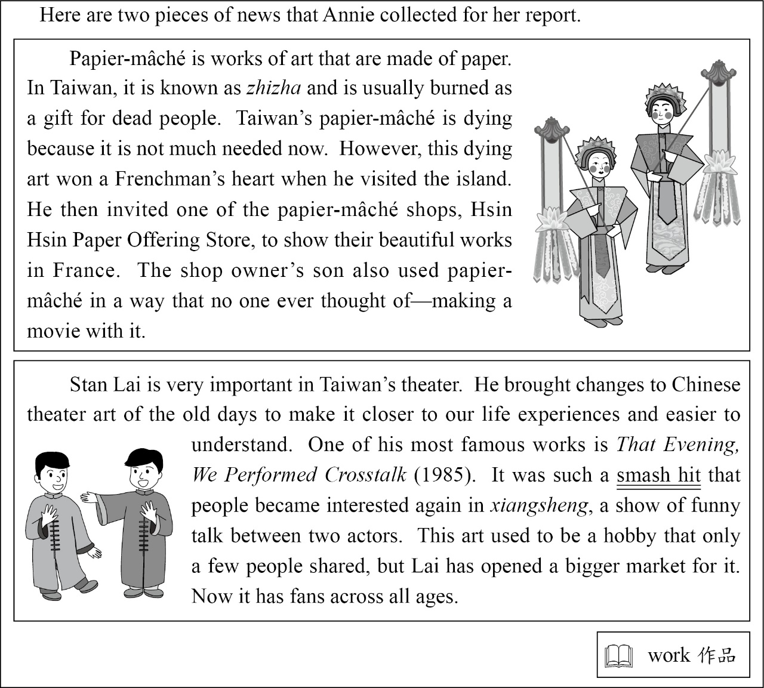

1.第28題評量學生找出已明確敘述的細節之能力。這類型題目作答時通常將選項與題幹文本訊息做比對後，與文本訊息敘述不符者以刪去法處理即可找到答案。本題答對率偏低可能是因為文本有不少陌生字詞令同學畏懼，如：zhizha, papier-mâché, offering, xiangsheng等，另一方面本題的兩篇報導語詞有豐富的訊息及交錯的人物關係，學生可能沒有釐清語詞的意涵及人物關係而選了錯誤的答案。

2. 在第一篇報導中，同學需要掌握三個訊息：(1)紙紮漸漸式微(dying)是因為現在比較不被需要了；(2)一個法國人來台灣後對紙紮藝術大為驚豔，並邀請新興糊紙店到法國做紙紮藝術的展覽；(3) 新興糊紙店老闆的兒子(the shop owner’s son)為紙紮藝術闢出一條新路，他利用紙紮來拍電影。有24.03%的同學選了(C)，可能沒有釐清人物間的關係，誤以為紙紮店老闆的兒子就是那位法國人。答案是選項(D) People do not burn papier-mâché for dead people as often as before.這個答案的線索是文本中Taiwan’s papier-mâché is dying because it is not much needed now.

3.在第二篇報導中，同學需要掌握三個訊息：(1)賴聲川導演將過往中國戲院藝術改變為和人們的生活經驗更貼近更易理解；(2)賴導演最有名的一個作品是「那一年我們一起說相聲」，當年這一部作品蔚為風靡，並且引起人們對這傳統藝術的興趣；(3)賴導演讓相聲藝術有了老少咸宜的市場。選項(A)賴導演在許多學教相聲，以及選項(B)賴導演經常將他的生活故事融入他的藝術作品都不是正確的敘述。

4.當文本訊息很複雜時，同學可以做簡單的摘要來找出文本的脈絡或人物間的關係。文本中出現沒看過的字彙時不要焦慮，請繼續閱讀文章並利用自己的背景知識來猜測作者可能是在描述何種事物；若用自己的經驗仍然猜不出來，要轉換思維，告訴自己可以利用作者提供的訊息來學習自己原先不知道的新事物。

*It’s never comfortable to take a bus during rush hour on a hot summer day. All my friends hate it. And I…, well, I*  57 *it too.*

*The story happened two months ago. I was on a bus that was packed with almost everyone in the city. I*  58 *my friend Neal to see a show. And then he called and said he couldn’t come. “This is not what I planned for Friday!” I thought. The air on the bus was terrible; the man in front of me smelled like dead fish. While I was feeling sorry for myself, a girl called my name. I didn’t recognize her at first. Then I was surprised to find that she was Hui-ting, my old neighbor. I*  59 *Hui-ting in years. We used to play together every day when we were kids. We were happy to see each other, so we decided to have dinner together. And that was the start of many dinners after.*

*With Hui-ting, the bus ride*  60 *something I love. The bus is still packed with people, but I enjoy the ride every day.*

*(Xiang Chang, Taipei)*

 rush hour 尖峰時間 recognize 認出

When I pick up my toy puppy

Out there on the high, high balcony?

Wish you could always be with me

And make them go away with your Do-Re-Me.

I remember last Halloween

They ran away when you started to sing,

“Dear Tommy, my little king,

Close your eyes and have a sweet dream.”

So please stay with me and sing

To stop them kicking the door, riding the wind,

And pulling me down to their house under the ground.

They’ll go away if you sing here for me,

In a voice that gets a black cat’s hair standing,

The strongest legs shaking, and the window glass breaking.

(ideas from Matthew Sweeney’s poem)

57. (A) hate (B) have hated

(C) used to hate (D) would hate

58. (A) used to meet (B) was going to meet

23.Which is most likely true about the speaker in the reading?

(A) He thinks a black cat is hiding somewhere in the house.

(B) He feels lonely because he is the only child in his family.

(C) He is looking for something he left somewhere in the house.

(D) He is afraid of being by himself when he feels ghosts around.

(C) have met (D) had met

59. (A) won’t see (B) wouldn’t see

(C) haven’t seen (D) hadn’t seen

60. (A) has become (B) had become

(C) will become (D) would become

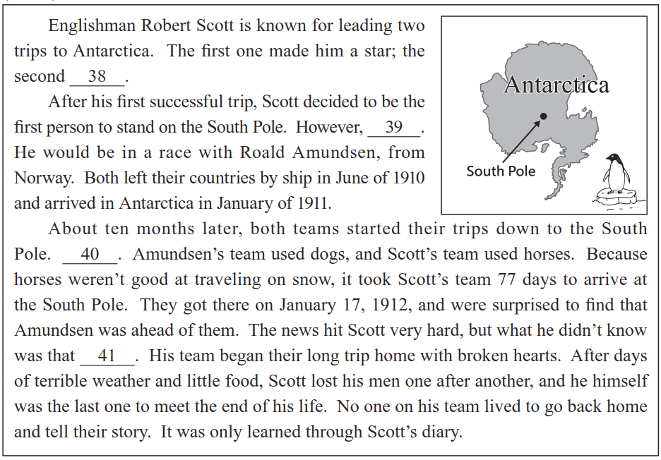

For years, we thought our Earth was the only blue dot up there. Now another has been found. Its name is HD189773b. HD189773b is an exoplanet, a planet outside our Solar System, and is one of the nearest exoplanets to Earth. Even so, 16 . Here’s why: It is 63 light years away.

That means it is 370,440,000,000,000 miles from us. Even if we fly at 3,500 miles an hour, it will take more than 12 million years to get there.

16. (A) we cannot really call it a neighbor

(B) we do not know anything about it yet

(C) we might not be able to stay there for long

(D) we are not sure how long it takes to get there

38. (A) hurt his health (B) opened his eyes

(C) cost him his life (D) made his dream come true

40. (A) And Scott used a popular way for his men to travel fast

(B) But there were problems to deal with before they traveled

(C) But Amundsen didn’t know better about animals than Scott

(D) And their ways of traveling decided which team would win

月考命題觀摩

認識規準與基準

